Calbay, Franz Arvin 4CSB

Cunanan, Patrick Bryan GE-ELEC Project

Francisco, Angelica Jane

Santos, Angel Luis

**Lagrange Polynomial Interpolation Method**

1. **Introduction**

The Lagrange Polynomial Interpolation method, published and named after Joseph Louis Lagrange (1975) and discovered by Edward Warring (1779), is used mostly for polynomial interpolation. This method is used when we want to describe the ups and downs in a data set and hit every point. The method can be a tool to create a polynomial that goes through any desired set of points.

1. **Formula**

The formula of the Lagrange Polynomial Interpolation Method is:

$f(x)= \frac{(x-x_{1})…(x-x_{n} )}{(x_{0}-x_{1})…(x_{0}-x_{n})}f_{0}+… \frac{(x-x_{0})…(x-x_{n-1} )}{(x_{n}-x_{0})…(x_{n}-x_{n-1})}f_{n}$

1. **Program**

The program is a developed using Java Programming Language. The program will ask first how many pairs will be inputted for the computation. After you have inputted the pairs, it will ask what is the value of X. After inputting the value of x, the program will solve the value of P(x) and the resulting equation based on the formula of the Lagrange Polynomial Interpolation.

The following is the solving function of the program:

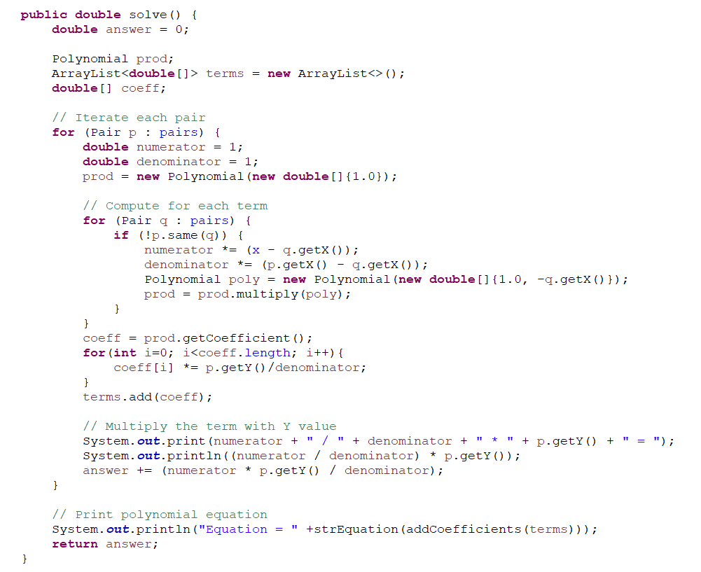

1. **Sample Outputs**

Sample Outputs of the Program:

Given: (12, 23), (23, 34), (34, 45), (45, 56), (56, 67); x = 10

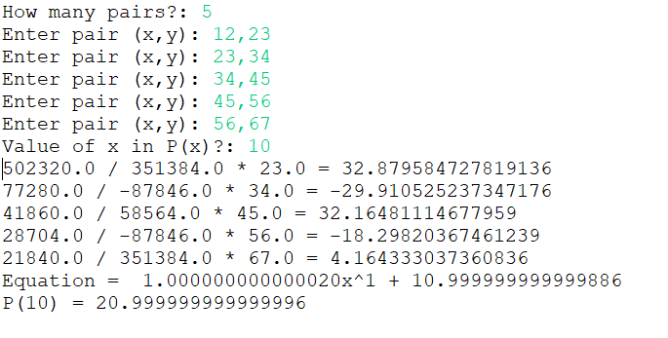

Given: (1, 3), (2, 4), (3, 5), (4, 6), (5, 7), (6, 8), (7, 9); x = 100

